Most of the content in this section is very similar to the first two projects, so not much will be required for this worksheet.

1. Use the Create feature to add a movie with the following information entered:

Title: Elf

ReleaseDate: 11/07/2003

Genre: Comedy

Price: 5.79

Do a screen print from the Movies/Index page showing the record was added.

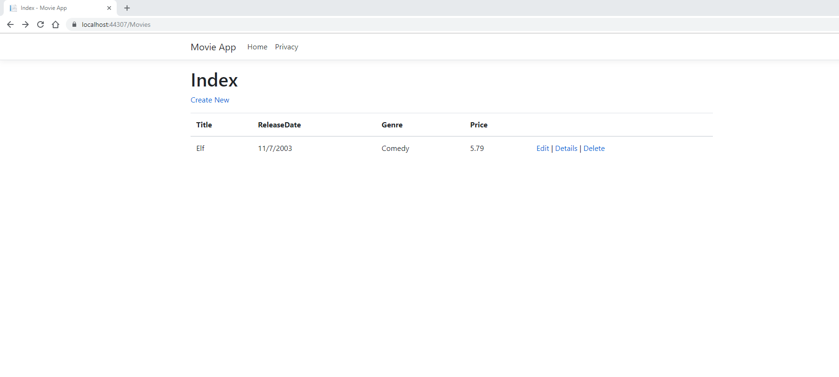

1. Use the Edit feature to change the Genre to Comedy/Romance.

Do a screen print from the Movies/Index page showing the record was modified.

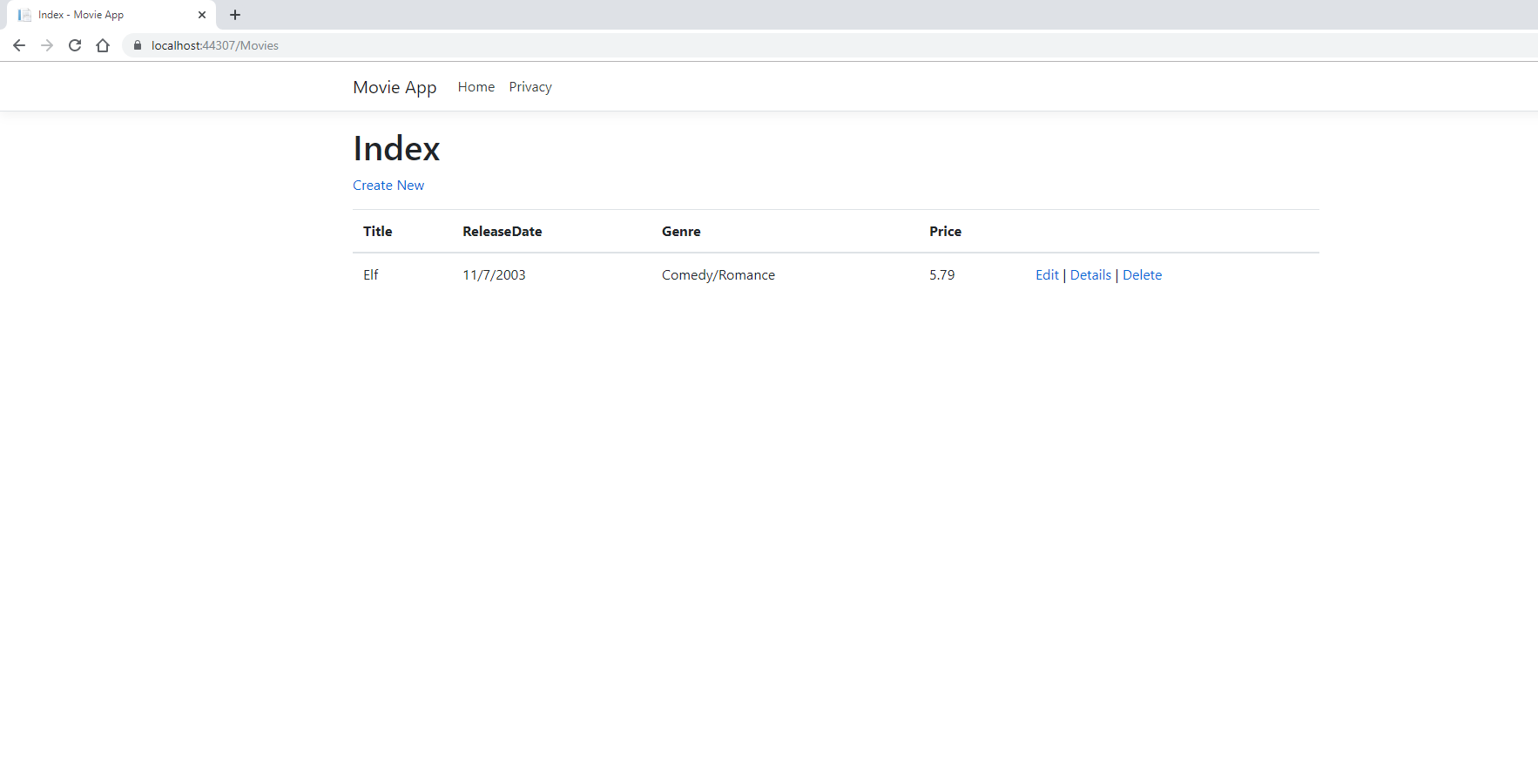

1. Use the Details feature to display the current information.

Do a screen print.

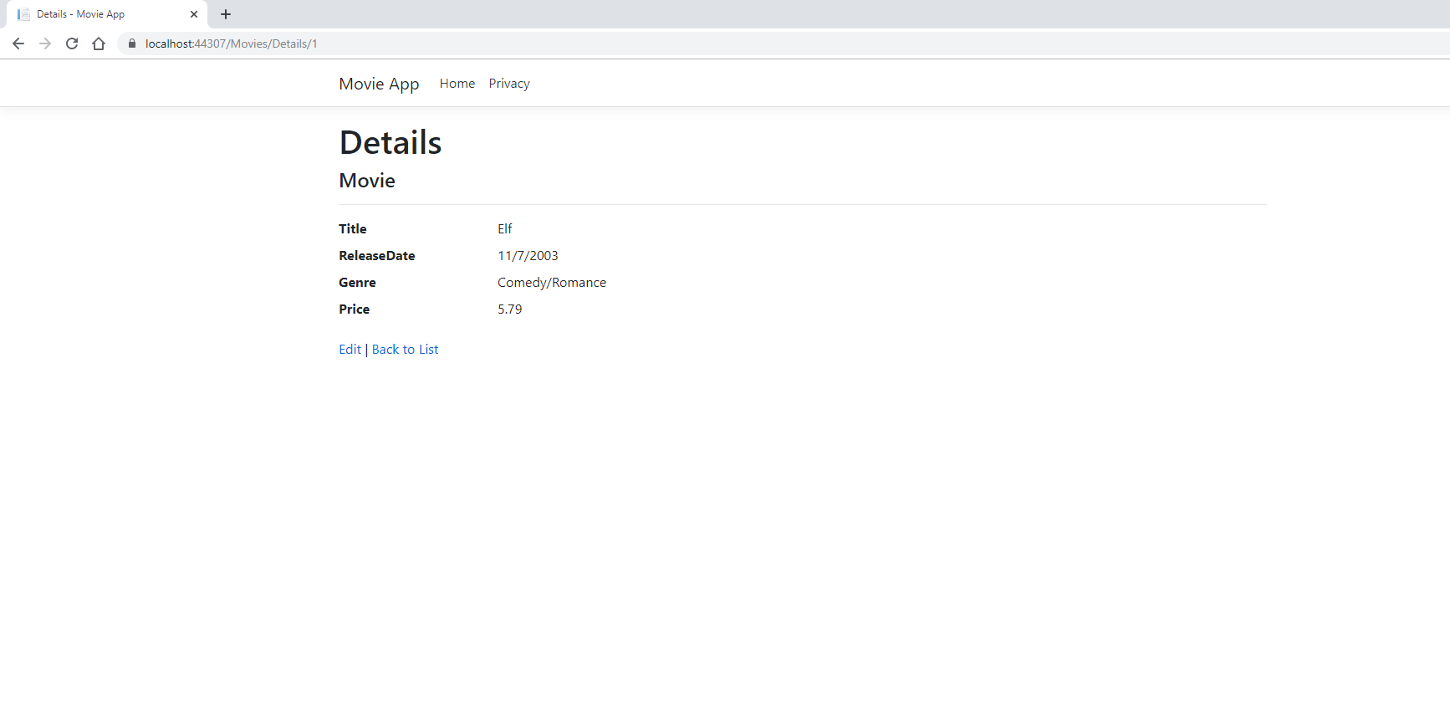

1. Use the Delete feature to remove the movie.

Do a screen print showing the record has been removed.

